**JUPYTER NOTEBOOK – INTRODUCTION**

Project Jupyter is a non – profit organization created to “develop open source software, open standards and services for interactive computing across dozens of programming languages.” Spun – off from **IPython** in 2014 by **Fernando Perez,** Project Jupyter supports execution environments in several dozen languages. The name Jupyter comes from the core supported programming languages that it supports : **Julia, Python and R**. Jupyter ships with the IPython kernel, which allows you to write programs in Python, but there are currently over 100 other kernels that you can also use.

Jupyter will always be 100% open – source software, free for all to use, and released under the liberal terms of the **modified BSD license**.

Jupyter is developed in the open on GitHub, through the consensus of the Jupyter community. For more information on our governance approach, please see our Governance Document.

All online and in – person interactions and communications directly related to the project are covered by the Jupyter Code of Conduct. The Code of Conduct sets expectations to enable a diverse community of users and contributors to participate in the project with respect and safety.

**Audience**

Jupyter notebook is a defacto standard interactive environment for data scientists today. This tutorial is useful for everyone who wants to learn and practice data science libraries of Python/R, etc.

**Pre – requisites**

This is not a tutorial to teach Python programming; instead it describes use of powerful interactive environment to use Python.

**Source : tutorialspoint.com/jupyter/index.htm**

**jupyter.org/about**

**realpython.com/jupytor-notebook-introduction/**

**STEERING COUNCIL**

The role of Jupyter Steering Council is to ensure through working with and serving the broader Jupyter community, the long – term well-being of the project, both technically and as a community. The Jupyter Steering Council currently consists of following members –

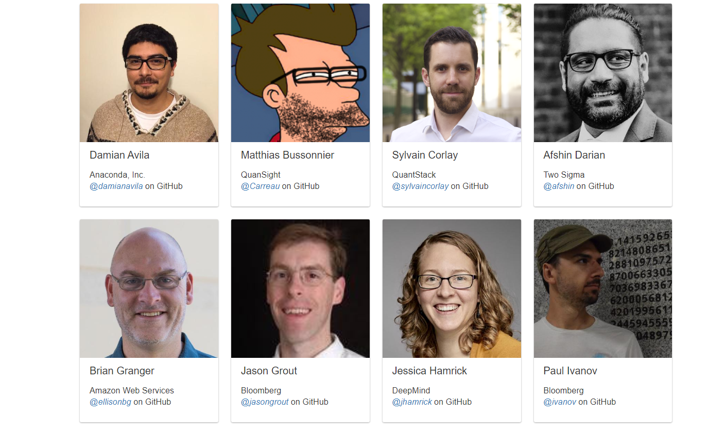

**Source : jupyter.org/about**

